**NILE UNIVERSITY**

Online Food Ordering Management System

A Software Engineering-CSCI313 Document

By

Rawan Ayman: 202001710

Doaa Gohar: 202000840

Merna Salem: 202000948

Nada Emad: 19200045

Trevena Ayman: 202000625

DR. Radwa M TAWFEEK

December 2023

Contents

**Introduction** 3

Purpose 3

Project Scope 3

Technologies used. 3

Intended Audience 4

Overview of the document 4

**Overall Description** 4

Product Perspective 4

User Characteristics 5

Operating Environment 6

Constraints 6

Assumptions and dependencies 6

**Functional requirements** 7

**User Functional Requirements** 7

User Registration and Authentication: 7

User Profile Management: 7

Restaurant and Menu Browsing: 7

Food Selection and Cart Management: 7

Order Placement: 7

Order Tracking: 7

Order History: 7

Notifications: 7

Search Functionality: 7

**Admin Functional Requirements:** 8

User and Restaurant Management: 8

Menu and Category Management: 8

Order Management: 8

Reporting and Analytics: 8

Notifications: 8

**Non-Functional Requirements:** 8

Availability: 8

Maintainability: 8

Performance: 8

Usability: 9

**System Interface**…………………………………………………………………………………………………………………………...……………………………………………………….……9

**Software interface**……………………………………………………………………………………………………………………………………..……………………………….……………..22

# **Diagrams** …………………………………………………………………………………………………………………….…………….….23

# **scrum video Recording**………………………………………………………………………………………………….…………………....2**7**

**Github Link**………………………………………………………………………………………………………………………………..…..27

# **Introduction**

## Purpose

A restaurant management system aims at streamlining and simplifying several operational processes in restaurants, so as to increase effectiveness, enhance the quality of customer service and optimize overall governance. The objective of the system is it offers a user-friendly and efficient website with a food menu, this system awakens to provide dining establishments and the customer with service facilities. Food ordering via the system online, managing menu information, and reporting are the services offered (Dishes Reports and Restaurant report). The admin shall be able, through the application of this system, to organise and monitor their operations in a way that will improve efficiency and customer satisfaction by reducing administrative errors and making timely business decisions.

## Project Scope

A robust software program to optimise all aspects of the restaurant's operation shall be developed and implemented within the scope of this project. The scheme will be implemented in such a way as to take account of the special needs and priorities of each restaurant, providing them with an effective online management tool for their establishment. A user-friendly website that offers a comprehensive menu of food, enabling customers to easily browse and select items is one of the key components of this system. The system makes it easier and more efficient to place online orders for food. Furthermore, detailed reports will be produced to manage the information on menus efficiently and make their own decisions. Important aspects such as sales figures and inventory control will be covered in these reports. In addition to make it easier for the customer to place online food orders and have them delivered using a helpful application.

In general, the scope of this project represents an integrated software solution to streamline restaurant operations, enhance customer service and facilitate data driven decision making.

## Technologies used.

• HTML (Hypertext Mark-up Language)

• PHP (Hypertext Pre-processor)

• My SQL database was used in the system's design and implementation.

## Intended Audience

• Client: To correspond with the team about the adjustments needed throughout each step.

• Developer: To have a guide with the required tasks to be implemented.

• Software Tester: To outline all the test cases that are set for the system and ensure that it meets the client’s requirements.

• Project Manager /SCRUM Master: To sketch the plan to follow throughout the project and ensure that the goals and tasks are clear and that the team works harmoniously.

## Overview of the document

This document constitutes a complete guide to the system of restaurants management, presenting an in-depth overview which details its aims, scope, technologies used, and intended audience. The introduction gives a concrete indication that effective restaurant management and the requirement of reliable software solutions are essential. It provides an overview of the project's purpose and describes how this system seeks to optimise different operational aspects of a restaurant. Following that, the document lays down the scope of the project and provides a description of the key modules and their corresponding roles in restaurant operations to give an overview of the particular functionalities and features which form part of the system. In addition, the document illustrates the technologies used for building this system. And finally, it provides information on the intended audience and stresses the importance of such a system for restaurant owners, Admins, and users.

In general, it provides guidance on the development and implementation of this restaurant management system to provide a thorough understanding of its purpose, scope, technologies used and intended audience.

# **Overall Description**

## Product Perspective

* The restaurant management system accommodates two user categories: customers and Admin. Each category has access to specific app functionalities tailored to their needs.
* The system utilizes a database to store and manage information, which is integral to the functioning of the app.
* the system is designed to satisfy Customers so they will purchase food from any location.

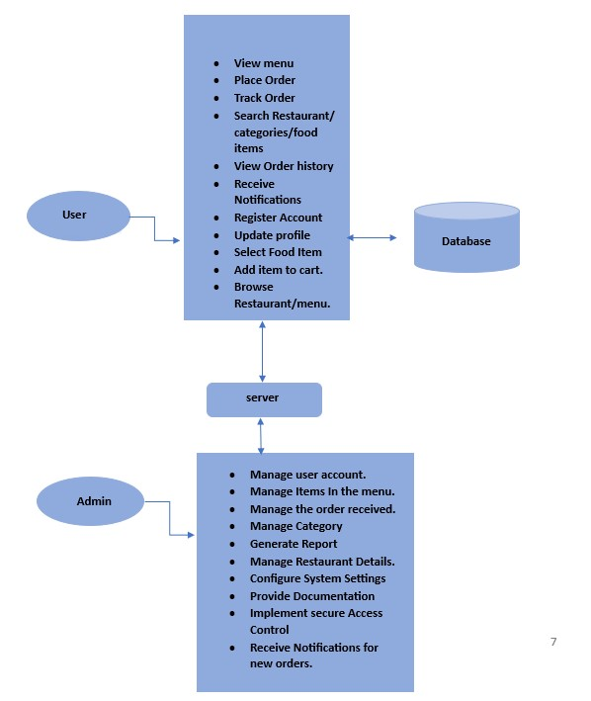

## User Characteristics

Users of the Restaurant management system can interact with the system by selecting items from the restaurant menu and adding them to their cart.

Users can search for specific restaurants or items within the system.

Users can track their orders to monitor the estimated delivery or pickup time.

Once the user adds items to their cart, the order is sent to the admin for processing.

The admin can manage user accounts, the items in the menu, including adding new items, editing existing items, and removing items from the menu.

The admin is also responsible for managing the orders received, including reviewing, and processing orders, updating order statuses, and communicating with users regarding their orders.

The admin can manage categories within the system, such as creating new categories, organizing items into categories, and modifying existing categories.

The admin has the capability to generate reports, such as sales reports, inventory reports, or user activity reports, to analyze data and gain insights into the restaurant's performance.

The admin is responsible for managing restaurant details, such as updating contact information, business hours, or location information.

The admin can configure system settings, including customizing the interface, setting up payment options, defining order fulfillment processes, and adjusting other system parameters.

The admin provides documentation or user guides to assist users in understanding and navigating the Restaurant management system effectively.

The admin implements secure access control measures, such as user authentication and authorization, to ensure that only authorized individuals can access the system and perform administrative tasks.

The admin receives notifications for new orders, allowing them to promptly review and process incoming orders. This feature helps in ensuring efficient order management and timely customer service.

## Operating Environment

The web application offers the best possible user experience on desktop and mobile devices because it is made to be responsive and accessible on a variety of devices.

The web application may be easily used by users with devices running a variety of operating systems, such as Windows, macOS, Android, and iOS.

## Constraints

For users to make orders easily, the online restaurant web application needs to be connected to the internet. To interacting with the ordering system and placing their meal orders, users must have a reliable internet connection. Real-time updates and modifications pertaining to placed orders are provided by the online application. Through the web interface, users may monitor the status of their orders, get notifications, and be aware of any changes made to their requests.

Software Constraints:

• HTML (Hypertext Mark-up Language)

• PHP (Hypertext Pre-processor)

• My SQL database was used in the system's design and implementation.

## Assumptions and dependencies

The administrative assistant needs to be proficient in English, have a reliable internet connection, and be quick to get all the orders to the kitchen.

# **Functional requirements**

## **User Functional Requirements**

User Registration and Authentication:

Users should be able to register for an account using a valid email or social media accounts.

The system should provide secure authentication mechanisms (password hashing, account verification).

### User Profile Management:

Users should have profiles containing personal information like name, contact details, and delivery address.

The system should allow users to update their profiles.

### Restaurant and Menu Browsing:

Users should be able to browse through a list of available restaurants.

Each restaurant should have a menu with categories and detailed food items.

### Food Selection and Cart Management:

Users should be able to select food items and add them to their cart.

The cart should display selected items, quantities, and the total price.

Users should be able to modify or remove items from the cart.

### Order Placement:

Users should have the ability to place an order from their cart.

During order placement, users should be able to choose the delivery address.

### Order Tracking:

Users should receive real-time updates on the status of their orders.

The system should provide an order tracking feature.

### Order History:

Users should have access to their order history, including details like items ordered, total price, and order status.

### Notifications:

Users should receive notifications for order confirmations.

### Search Functionality:

Users should be able to search for specific restaurants, categories, or food items.

## **Admin Functional Requirements:**

### User and Restaurant Management:

Admins should be able to manage user accounts, including adding, updating, or deactivating accounts.

Admins should have the capability to manage restaurant details, including adding new restaurants.

### Menu and Category Management:

Admins should be able to manage food menus and categories for each restaurant.

The system should allow admins to add, update, or remove menu items.

### Order Management:

Admins should have access to a dashboard displaying order statistics.

They should be able to view, process, and change the status of orders (processing, delivered, rejected).

### Reporting and Analytics:

Admins should be able to generate reports on the performance of restaurants and food items.

### Notifications:

Admins should receive notifications for new orders and customer queries.

# **Non-Functional Requirements:**

## Availability:

The restaurant app system should be able to operate 24 hours a day, seven days a week to accommodate customers' needs at any time.

## Maintainability:

It is important to make a system that can be easily updated and expanded in the future. To enable new features or modifications to be made, without significantly disrupting the whole system, this includes a Modular Architecture, well documented codebase and continuous application of programming best practices.

## Performance:

The application should be highly usable, so as to ensure that the loading time of basic features such as menu browsing, order placement and payment processing are not over a certain threshold. For example, in order to ensure a smooth user experience, the response time for such actions should be within 1-2 seconds.

## Usability:

The restaurant app should be user friendly and easy to use for both customers and Admin.

Let's look at the following objectives:

* Without having to deal with much difficulty or confusion, customers should be able to easily use the application, browse menus, place orders and make payments.
* The admin of restaurants should have a simplified interface for ordering, updating menu items and responding to customers' requests. The system should be structured in such a way as to reduce the risks of user error and minimize the amount of training required.
* The aim of the application is to be designed in such a way that customers and Admin can get started with its key functions without previous training. Nevertheless, in order to ensure effective onboarding, training should not be continuous for more than several hours if it is necessary.

# **System Interface**

## Screenshots for the GUI:

**Log in**

The log in page for the user.

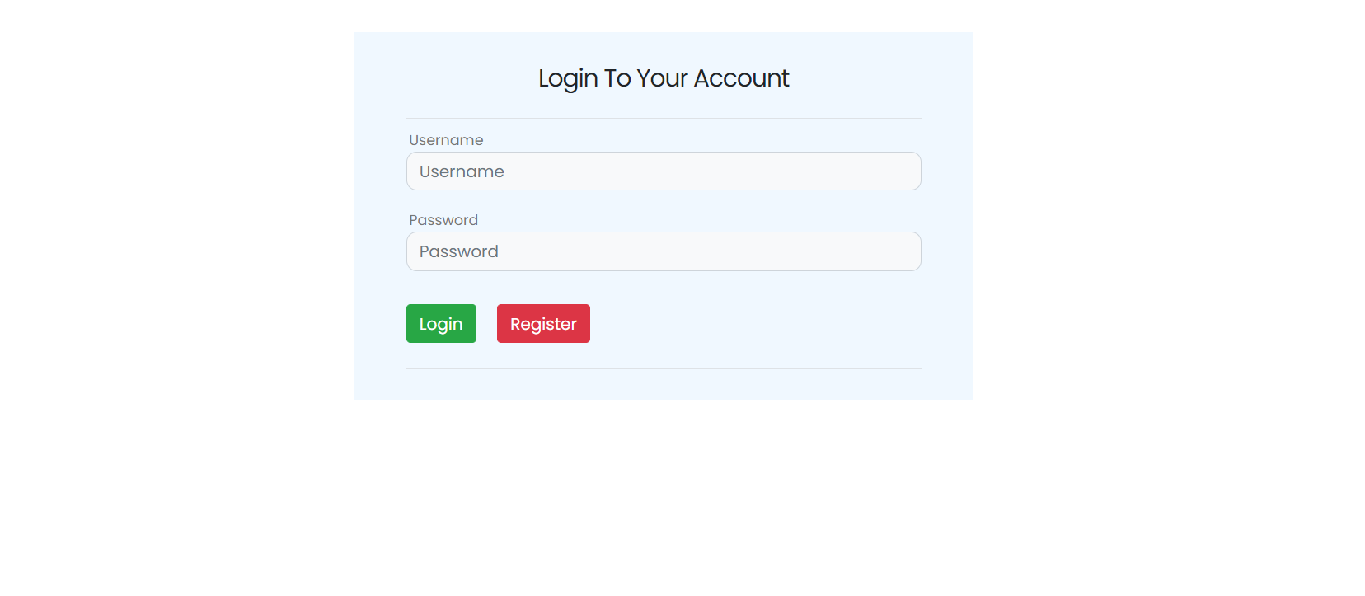

**Home Page**

User home page that the user can navigate through it.

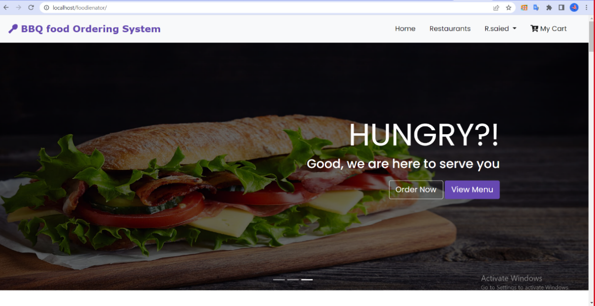

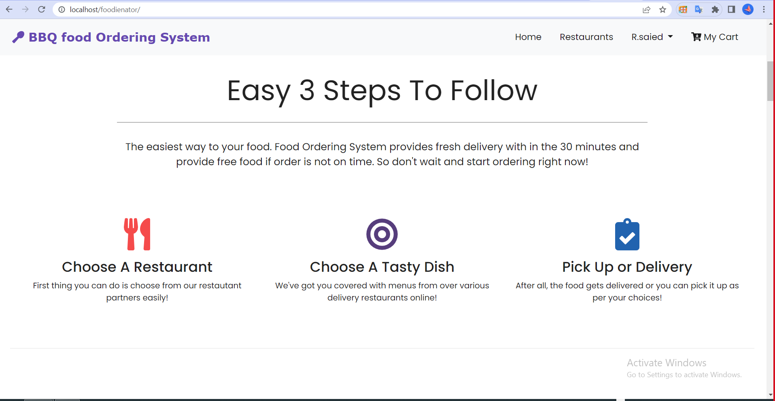

**Popular Dishes Page**

Popular dishes which are in the home page.

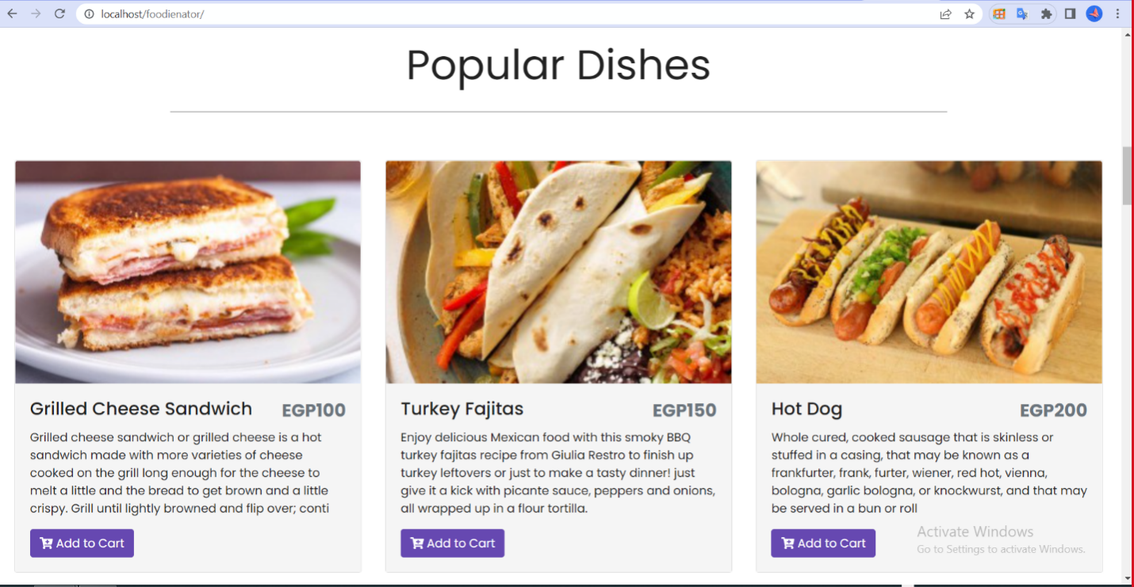

**Admin Dashboard**

Admin log in page, by which username and password are entered

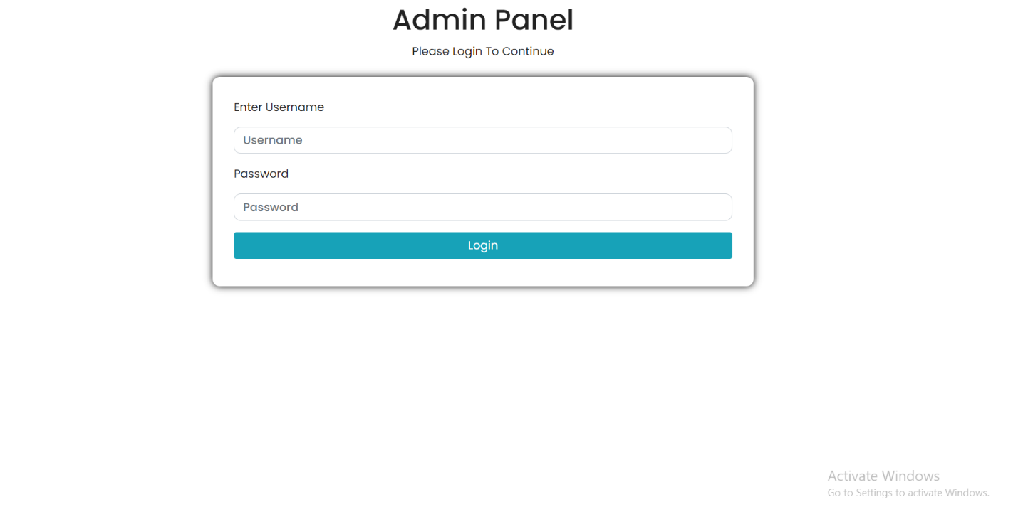

**User**

* Manage User: Admin can see the information of the app users.

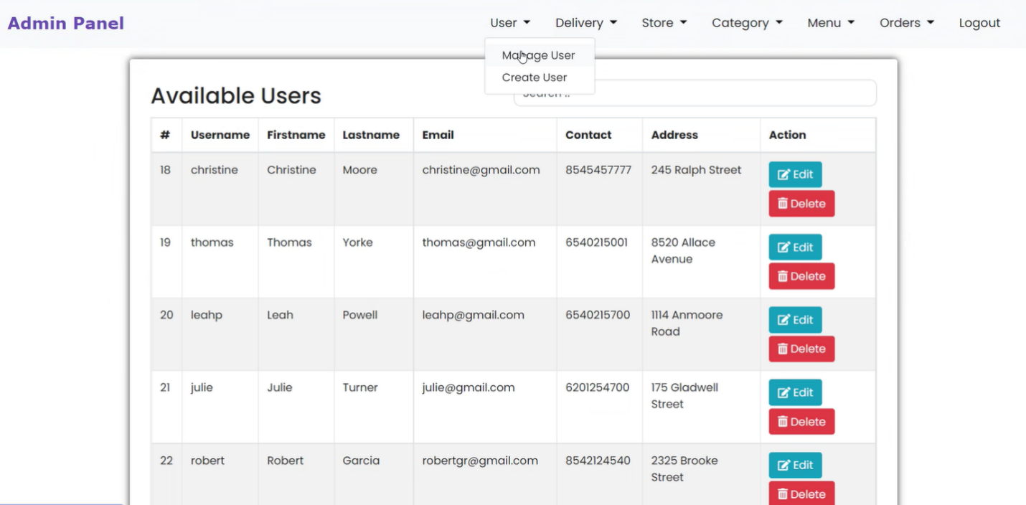

* Create User: Admin can create users by entering their listed information.

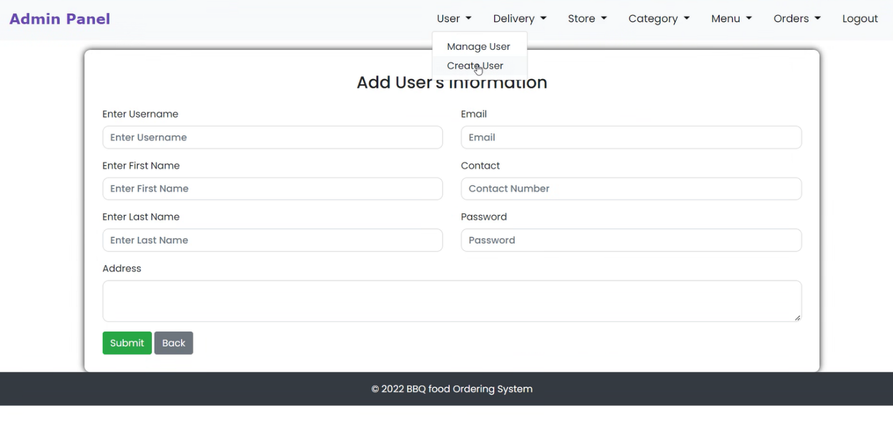

**Delivery**

* Manage Delivery: Admin can Manage Delivery Information through this page.

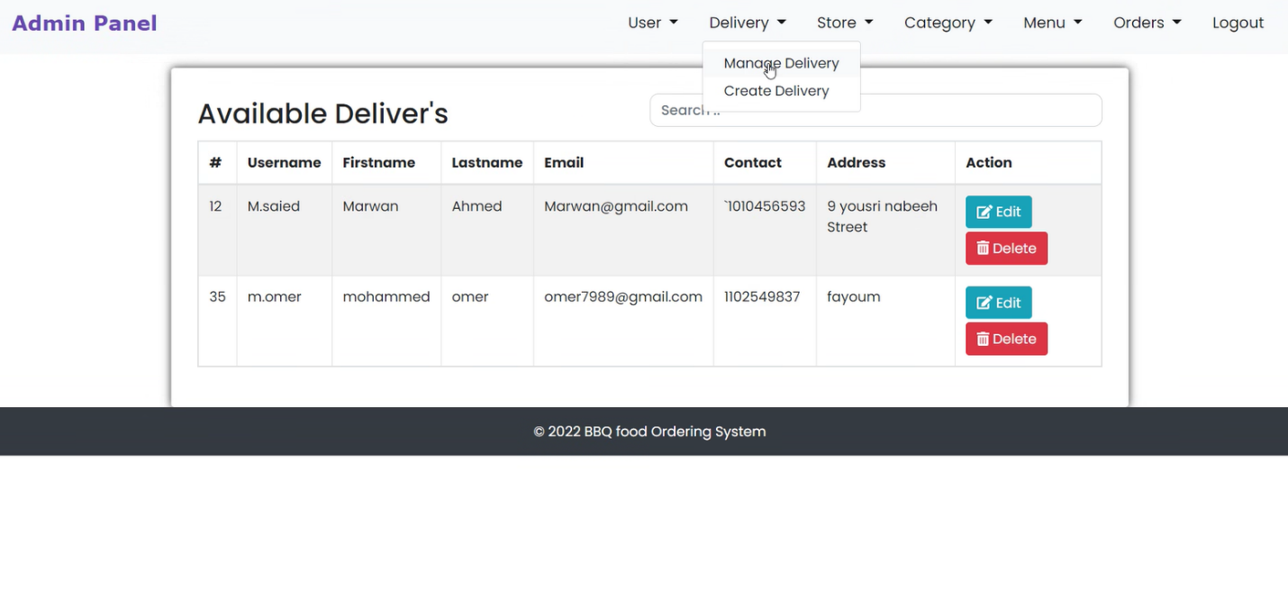

* 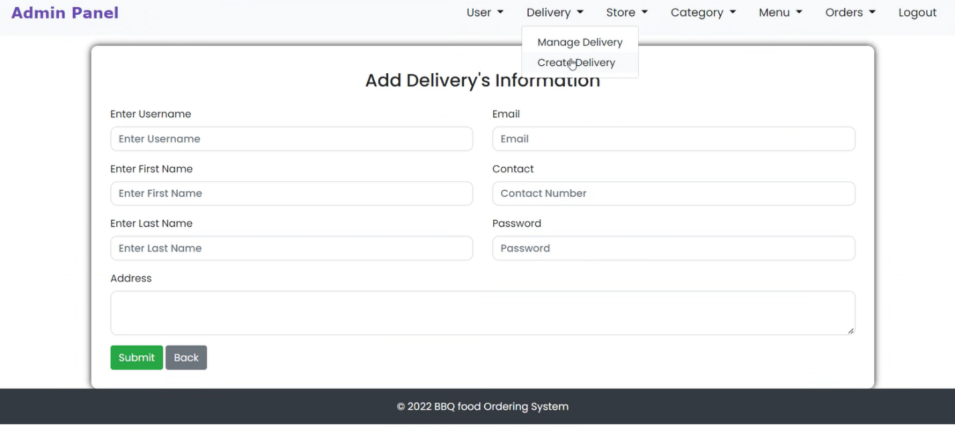Create Delivery: Admin can Create a new delivery Boy through this page

**Store**

* Manage store: Admin can see the stores information which are in the system.

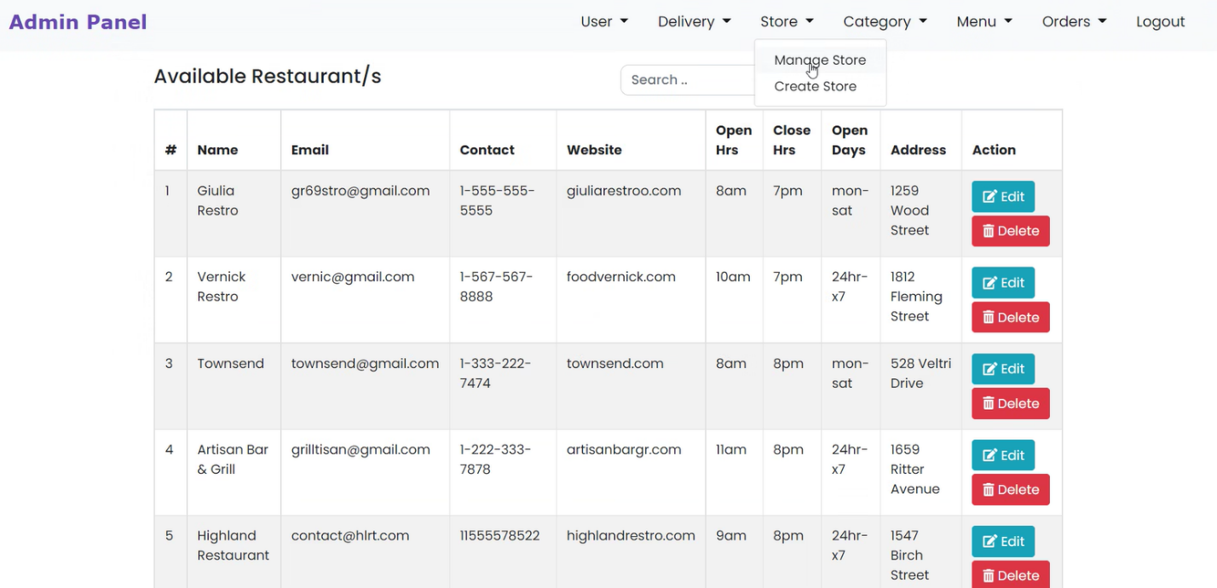

* Create Store: Admin can Add New store to the system through this page.

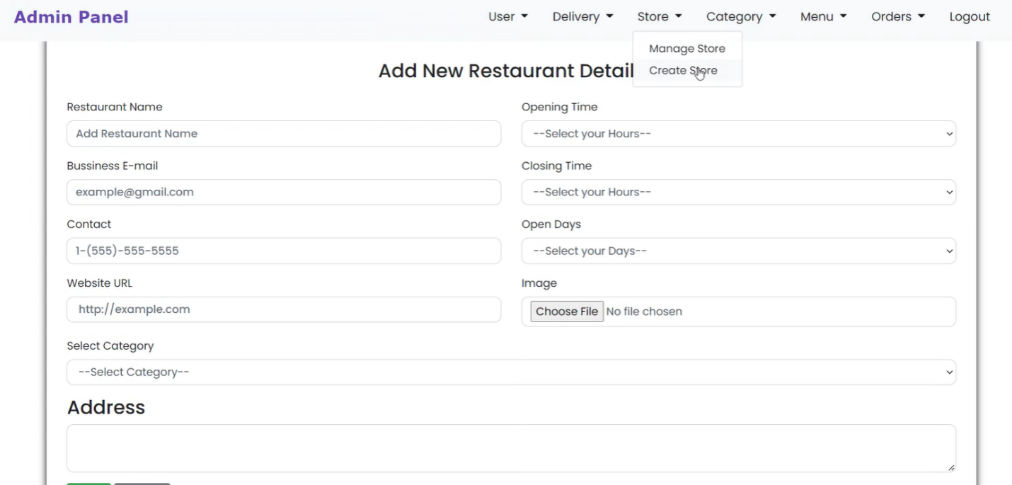

**Category**

* Manage Category: Admin manage which category each restaurant falls into.

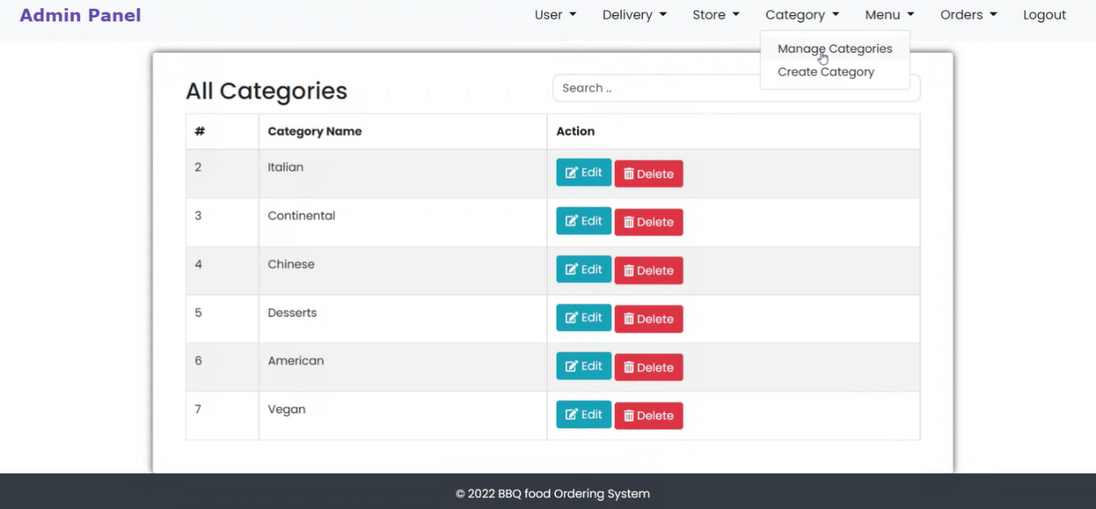

* Create category: Admin can create new category to be added to the system.

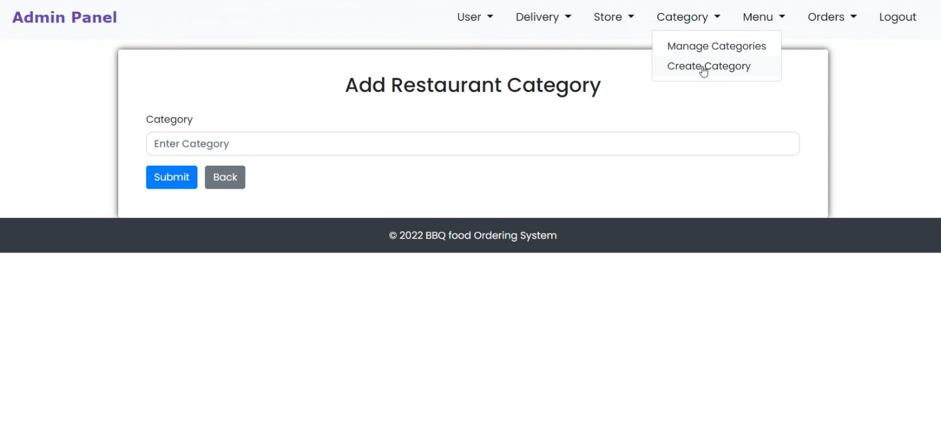

**Menu**

* Manage Menu: Admin can manage menu and see how many dishes of each item are available.

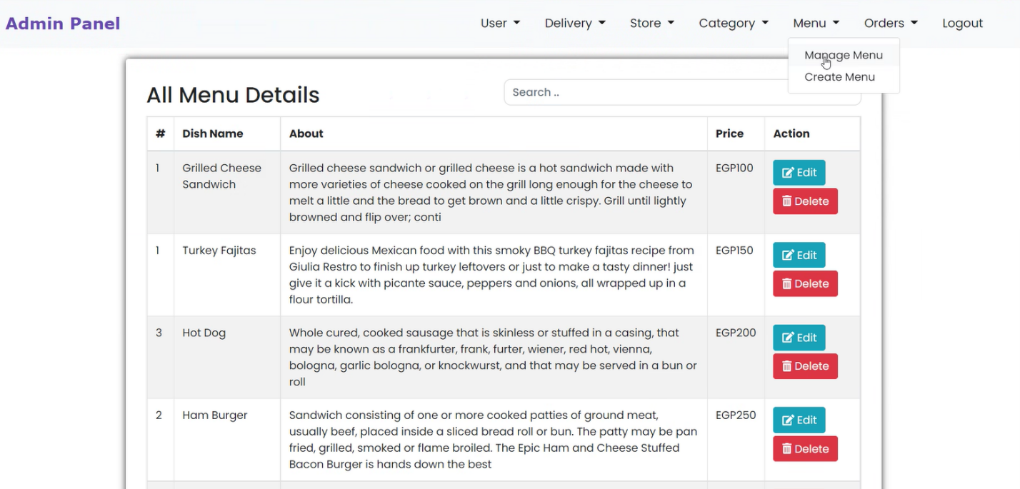

* Create Menu: Admin can create a new menu for any restaurant he/she selects.

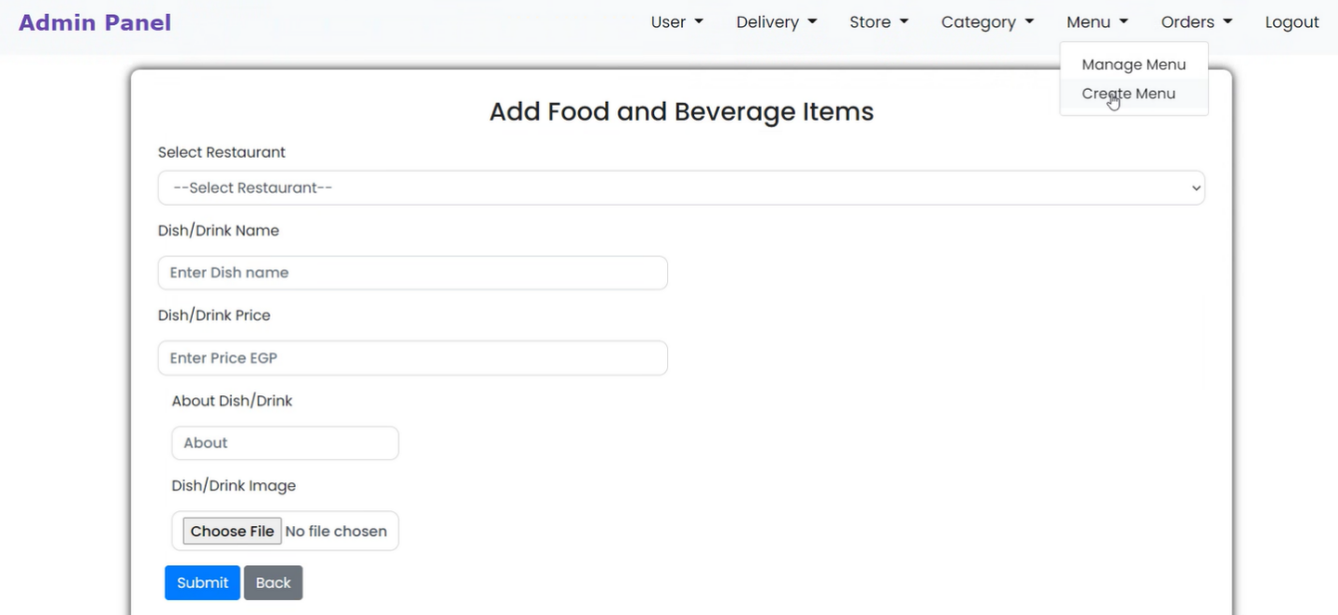

**Orders**

* All Orders: Admin keeps track of the orders to see orders status.

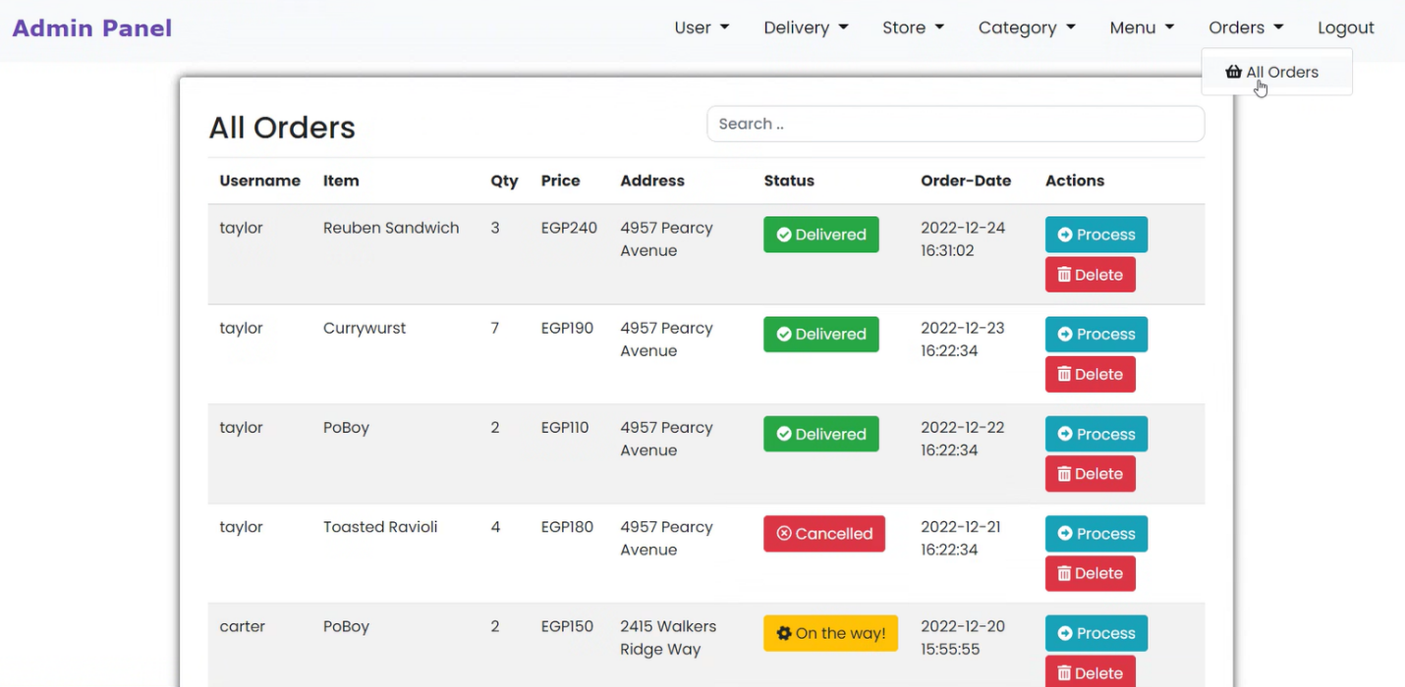

Process Button to check View User’s order.



Admin can see order information and select order status.

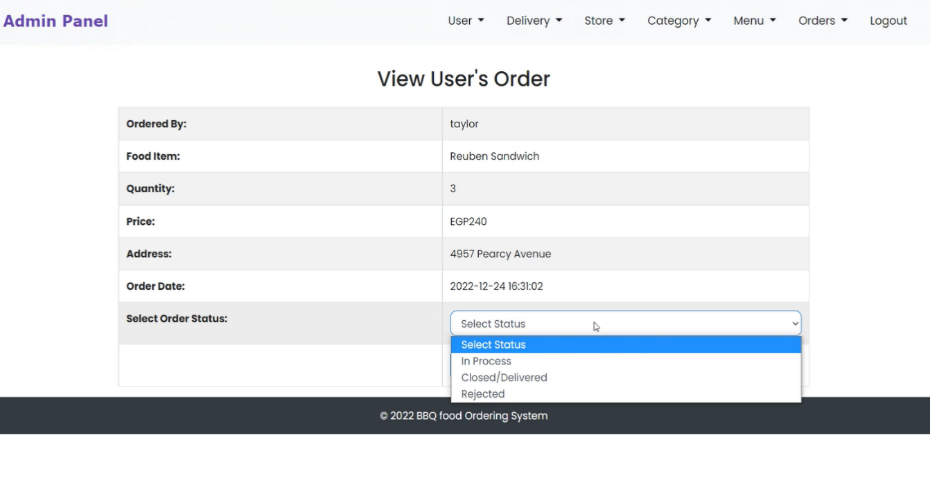

**Customer Dashboard**

* Home Page: Customer can navigate through this page.

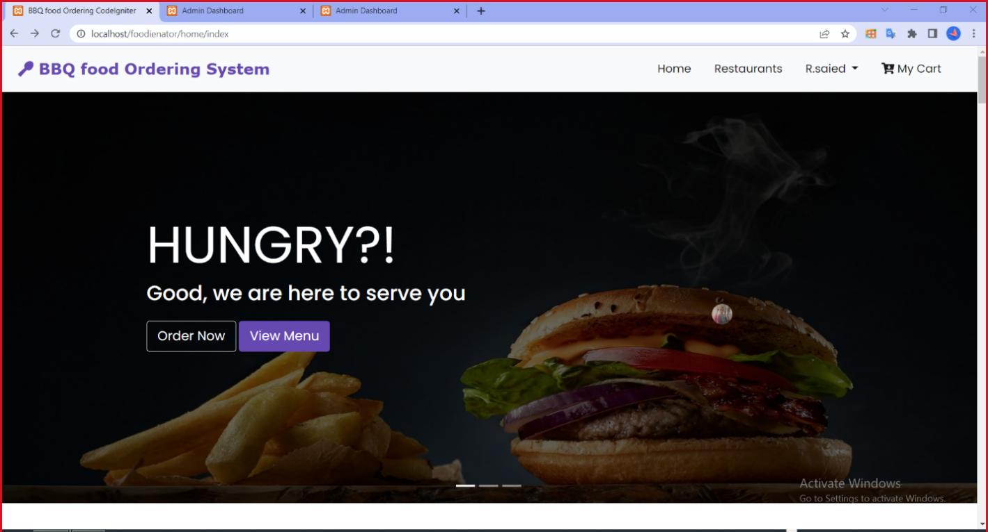

**How to Make Orders**

1. My Cart: Customer can view his/her shopping cart to see what was added.

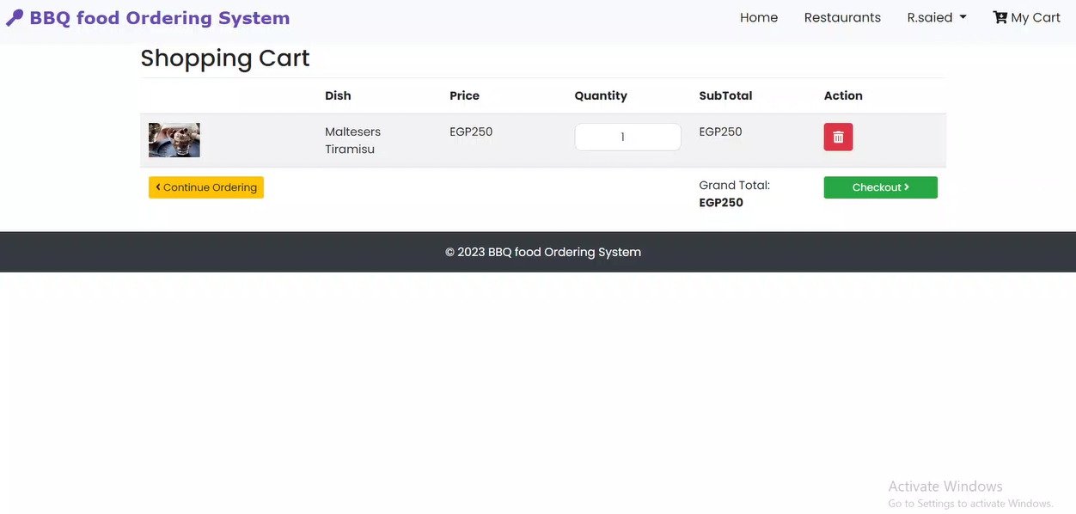

1. Checkout: Customer can proceed to checkout.
2. Order Preview: Customer preview his/her order then place it.

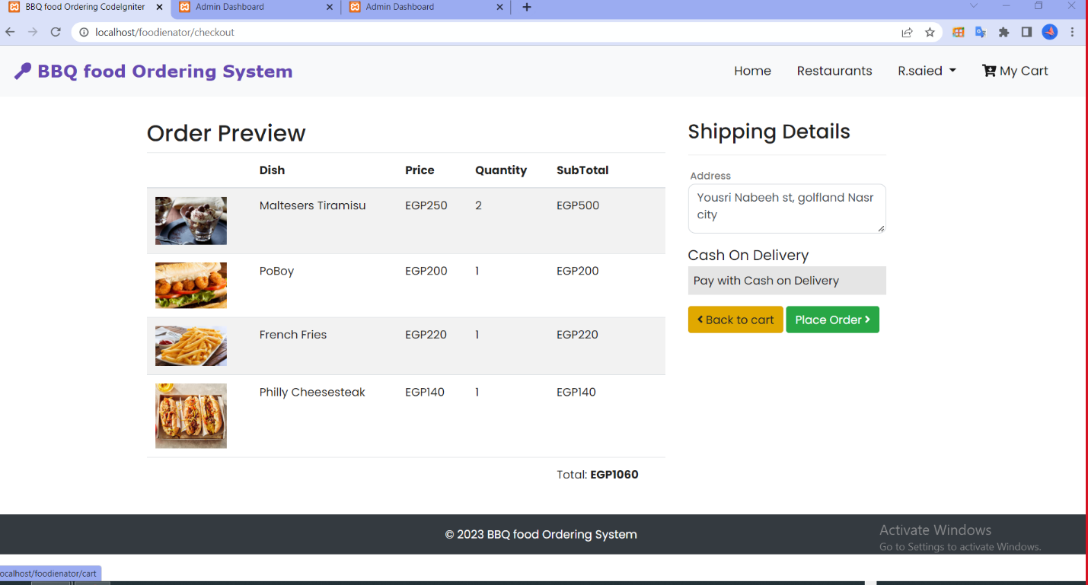

1. Recent Orders: Customer can view the recent order details he/she made.

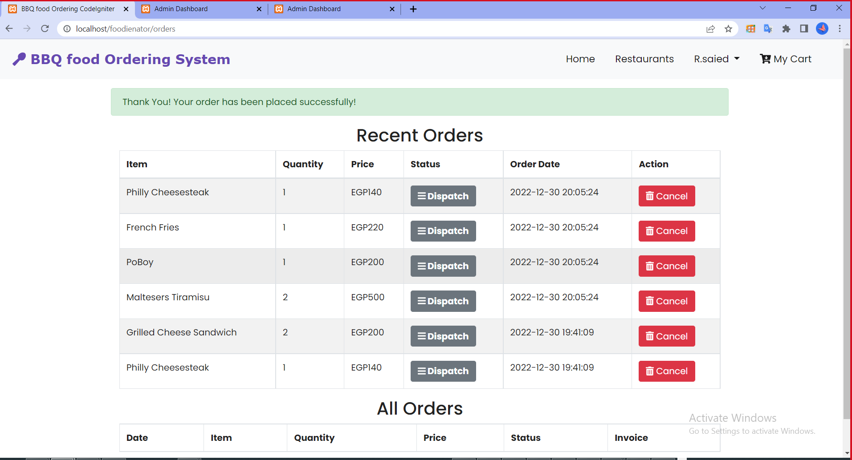

**Restaurants**

Customer can see all the restaurant on the system to choose between and view their menus.

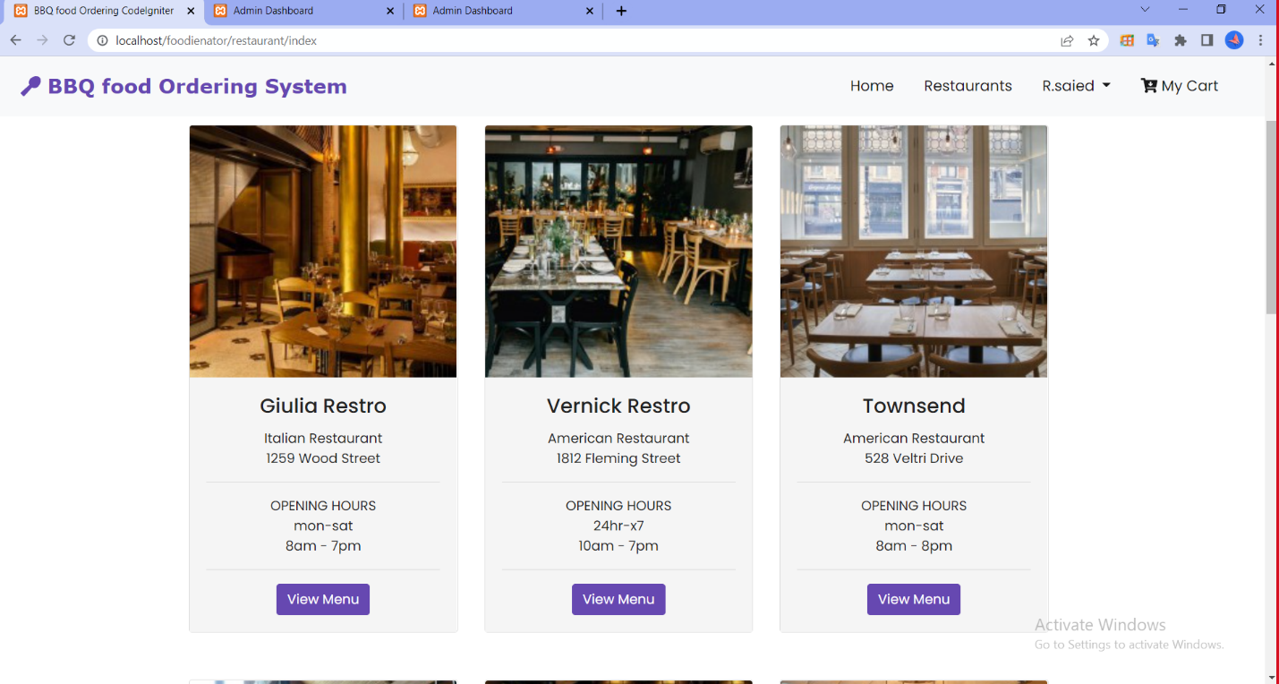

**User profile**

Account Setting: User can edit their account settings and save the changes then.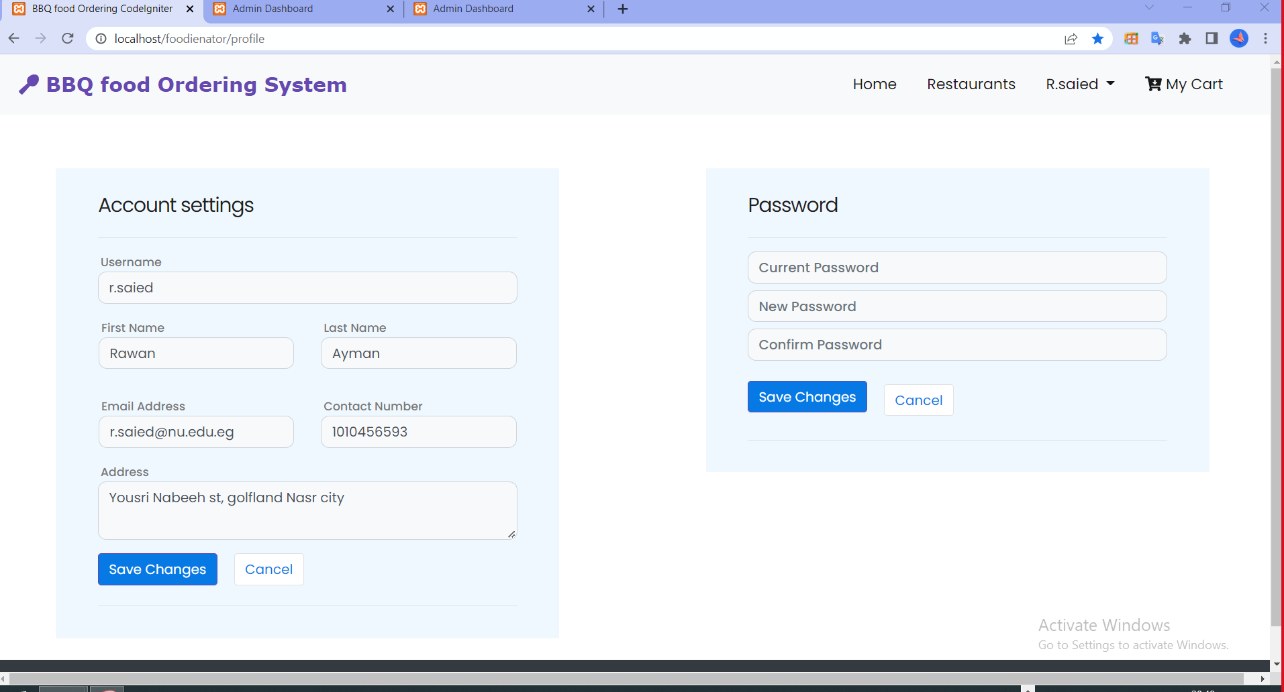

# **Software Interface**

The BBQ food ordering website application was created using the HTML (Hypertext Mark-up Language), PHP (Hypertext Pre-processor), My SQL database and Visual Studio Code editor were used in the system's design and implementation.

# **Diagrams**

1. **Use Case Diagram**

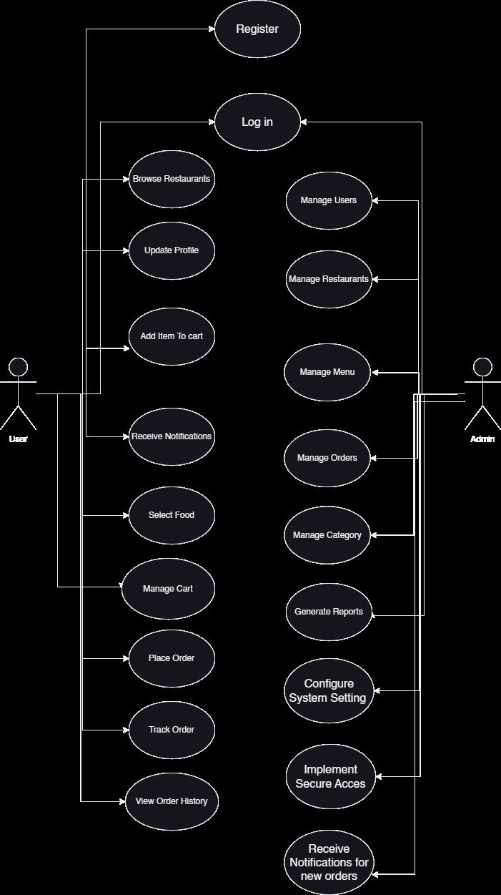

1. **Sequence Diagram**
2. **User**

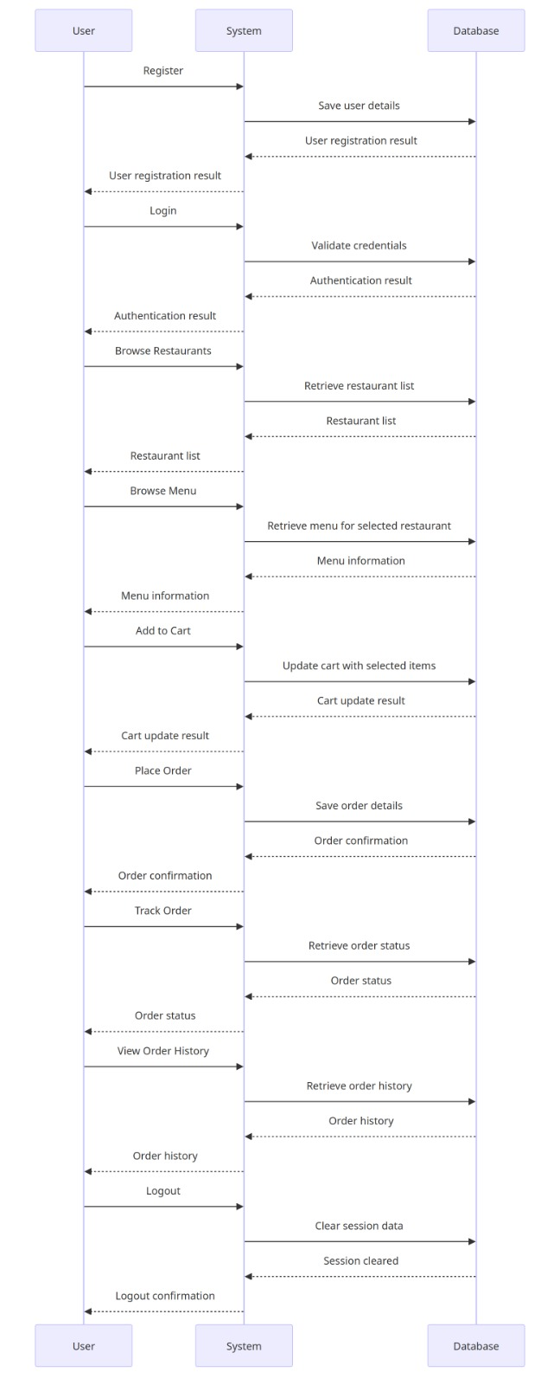

1. **Admin**

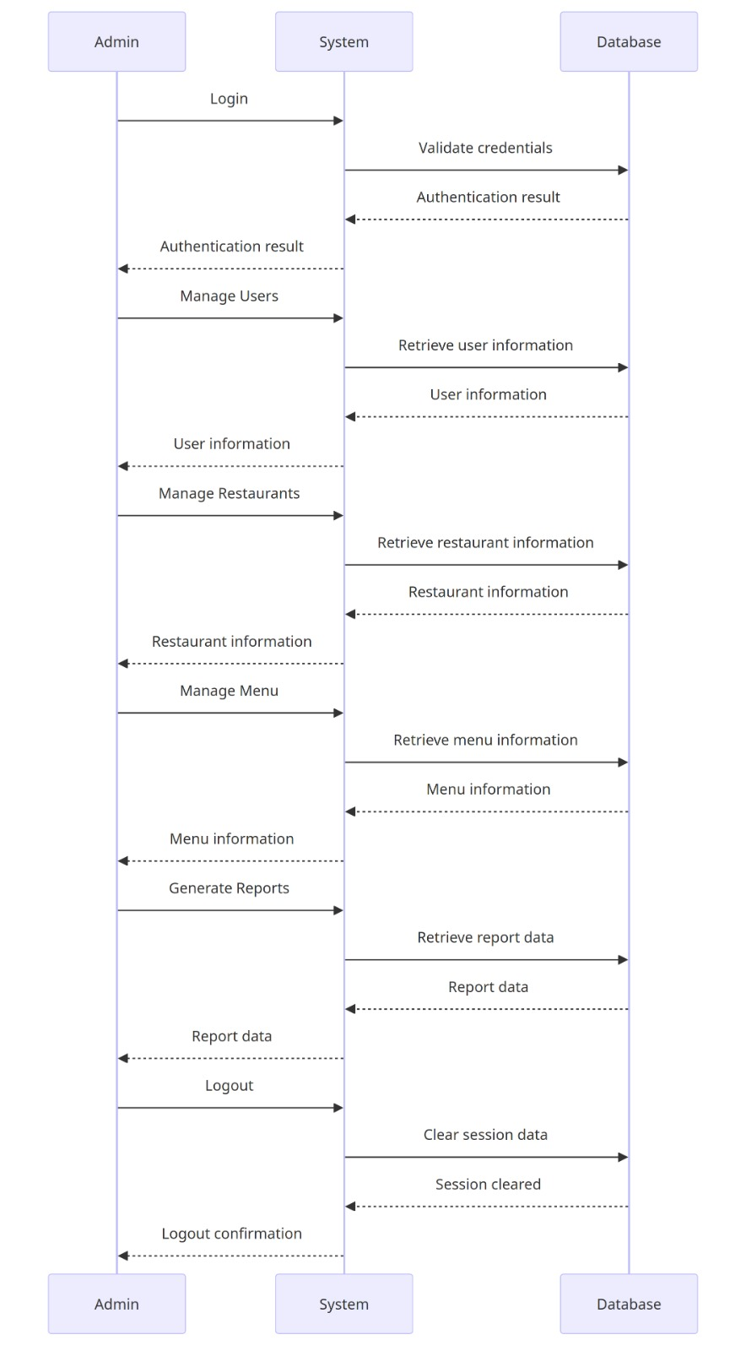

1. **Class Diagram**

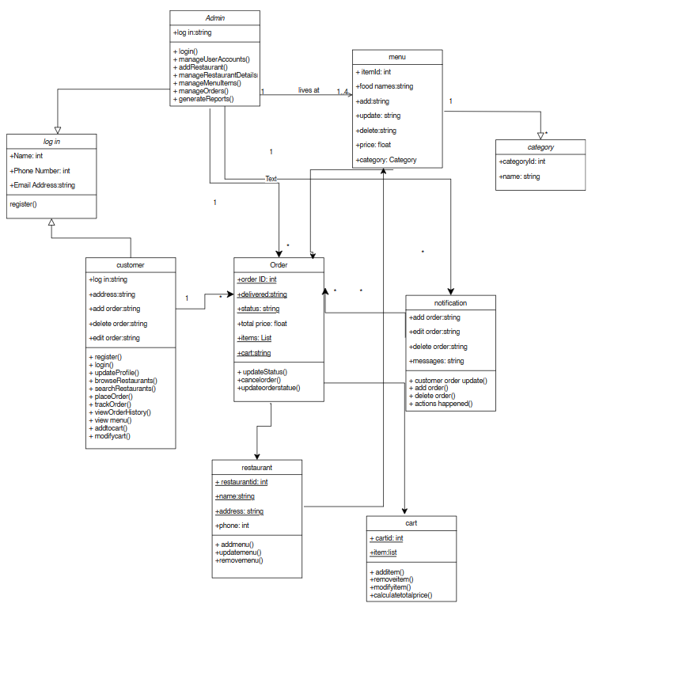

# **Scrum Video Recording**

[**https://nileuniversity.sharepoint.com/sites/SoftwareEngineering446/Shared%20Documents/General/Recordings/Meeting%20in%20_General_-20231216_214744-Meeting%20Recording.mp4?web=1**](https://nileuniversity.sharepoint.com/sites/SoftwareEngineering446/Shared%20Documents/General/Recordings/Meeting%20in%20_General_-20231216_214744-Meeting%20Recording.mp4?web=1)

# **Github Link**

[**https://github.com/mernasalem1/Software-Project**](https://github.com/mernasalem1/Software-Project)